

EVEREST ENGINEERING COLLEGE
(AFFILIATED TO POKHARA UNIVERSITY

A Minor Project Proposal
On
STOCK MARKET ANALYSIS AND FORECASTING

Submitted By:
Anish Acharya [21075396]
Bhuwan Prasad Joshi [21075406]
Chetan Babu Bhat [21075409]
Pradeept Jarur Shahi [21075421]

Submitted To:
Department of Computer and IT Engineering
Everest Engineering College
Sanepa-2, Lalitpur

Dec 27, 2024

ACKNOWLEDGEMENT
We are eternally grateful to the members of the panel committee to provide us an opportunity to present this project and we are hopeful that we receive your valuable insights, constant encouragement and expert guidance throughout the project interval. Your mentorship and thoughtful feedback could prove instrumental for successful completion of this project. We express our deepest appreciation in regards to your guidance and unwavering support.
A special thanks to our fellow classmates and friends for their insightful discussion and motivation during the planning and initial phase of the project. We expect such collaboration and motivation throughout the project term. We deeply appreciate your actions and collaboration

ABSTRACT
Stock market forecasting is one of the biggest challenges in the financial market since its time series has a complex, noisy, chaotic, dynamic, volatile, and non-parametric nature. However, due to computing development, an intelligent model can help investors and professional analysts reduce the risk of their investments. As Machine Learning models have been extensively studied in recent years, several studies have explored these techniques to predict stock prices using historical data and technical indicators. However, as the objective is to generate forecasts for the financial market, it naturally becomes important that the forecast should be profitable. Therefore, this systematic review focuses on Machine Learning models implemented for stock market forecasting using technical analysis. Discussions were made based on four main points of view: predictor techniques, trading strategies, profitability metrics, and risk management. This study showed that the LSTM technique is widely applied in this scenario (73.5%). This work significant contribution is to highlight some limitations found in the literature, such as only 35.3% of the studies analysed profitability, and only two articles implemented risk management. Therefore, despite the widely explored theme, there are still interesting open areas for research and development.

Table of Contents

ACKNOWLEDGEMENT i
ABSTRACT ii
Table of Contents iii
List of Figures v
List of Tables vi
ABBREVIATIONS vii
Chapter 1: INTRODUCTION 1
1.1. Background and Problem Statement 1
1.2. Objectives 1
1.3. Scope and Applications 1
Chapter 2: LITERATURE REVIEW 3
2.1. Deep Learning for Finance: Deep Portfolios 3
2.2. ARIMA Model for Forecasting Stock Prices 3
2.3. The Performance of LSTM and BiLSTM in Forecasting Time Series 4
2.4. NSE Stock Market Prediction Using Deep-Learning Models 4
2.5. Stock Price Prediction Using Machine Learning and LSTM-Based Deep Learning Models 4
Chapter 3: METHODOLOGY 5
3.1. System Block Diagram 5
3.1.1. Data Collection and Preprocessing 5
3.2. Tools and Technologies 6
3.3. System Development Life Cycle (SDLC) 6
3.4. Assumptions 7
3.5. Machine Learning Algorithms 7
3.6. Data Collection 8
Chapter 4: Implementation 9
4.1. Problems Faced 9
4.2. Work Completed 10
4.3. Work Remaining 11
Chapter 5: Expected Output 12
5.1.1 Performance Metrics 12
Chapter 6: Project Schedule 13
6.1. Schedule 13
Chapter 7: CONCLUSION 14
REFERENCES 15

List of Figures

Fig. No. Title Page Number
Figure 1: Block Diagram of Stock Prediction using LSTM model 5
Figure 2: Iterative and Incremental Model 6
Figure 3: Problem 1 9
Figure 4: Data collection chart 10
Figure 5: Actual price vs Predicted price 12

List of Tables

Table Number Title Page Number
Table 6.1 Gantt Chart 13

ABBREVIATIONS

LSTM Long Short-Term Memory
RNN Recurrent Neural Network
DL Deep Learning
ARIMA Autoregressive Integrated Moving Average
ML Machine Learning

Chapter 1: INTRODUCTION

Background and Problem Statement
The stock market is an essential part of the global economy, providing opportunities for investment and financial growth. However, predicting stock prices often invites many difficulties as the stock markets are highly dynamic, volatile and are influenced by many factors such as company news, political factors, market sentiment, inflation, market manipulation etc. Traditional methods often cannot handle the non-linear and complicated patterns of stock market data. Therefore, more refined and advanced techniques/models are required.
With the development of computing and data science, Machine Learning (ML) has become a powerful tool for predicting various data. ML models can analyse large amount of past data and identify hidden patterns that are difficult to detect using traditional methods. Among these models, Long Short-Term Memory (LSTM) is a popular model especially used with time-related data.
Despite many studies and research regarding use of ML for stock market forecasting, many focus solely on prediction accuracy while disregarding factors such as profitability and risk management. This is a problem because the main goal of stock market forecasting is not just to make accurate predictions but also to make profitable and safe investments.

Objectives
The objective of this project is to analyse the stock market of Nepal using LSTM and further forecast the market trend based on that analysis.

Scope and Applications
        - Stock Market Forecasting: The LSTM model can be applied to predict short-term and long-term stock price movements, aiding traders, investors, and financial institutions in making informed decisions.
        - Risk Management: By predicting potential price fluctuations, the model can help risk managers identify periods of high market volatility and adjust strategies accordingly.
        - Financial Advisory Services: Financial advisors and consultants can incorporate the model’s forecasts into their advisory services, offering clients data-driven insights into market trends.

Chapter 2: LITERATURE REVIEW
This review takes lot of study and analysis into its domain field which is deep learning, the strategy of trading and the stock market data.

2.1. Deep Learning for Finance: Deep Portfolios
J.B. Heaton et.al [1] explore deep learning algorithm to solve problem that are arising in financial prediction. It also stated that how deep learning predictor is more efficient and productive in getting result than traditional predictors. It also clarifies that it is easy to handle correlation and how to avoid over fitting.
In this research world it is easily be seen that there are lot of deep learning algorithm. So finding the perfect deep learning algorithm for prediction is a mammoth task. It requires lot of study to find which is the best. Our study also requires to study about different type of algorithm and to see which is the best model. Torkil Aamodt find that Convolutional neural network had efficient result.

2.2. ARIMA Model for Forecasting Stock Prices
Mondale et.al [2] study and apply the Arima model to predict the accuracy of stock price prediction. This model was identified by using Akaike information criteria and it is found if there is change in training dataset than the variation in accuracy is little. To determine the accuracy, mean absolute error is the efficient way. LSTM had been proven successfully for time series prediction. Hengijian jia et al. proposed that the LSTM algorithm learn the stock price pattern in effective way and by applying this approach it gets lower MAE and RMSE value. This study helps to identify this problem as time series prediction and to use sliding window technique to get the better result.

2.3. The Performance of LSTM and BiLSTM in Forecasting Time Series
Sima Siami-Namini [3] in his research found that LSTM overcomes the Arima based model by a large margin and it is approx. 84 and 87 percent. The research also clarifies that when we expand the number of iteration then it does not increase the model efficiency in the stock price prediction. It has been reported that artificial Recurrent Neural Networks (RNN) with memory, such as Long Short-Term Memory (LSTM), are superior compared to Autoregressive Integrated Moving Average (ARIMA) with a large margin.

2.4. NSE Stock Market Prediction Using Deep-Learning Models
Hiransha [4] used an approach for predicting stock data using RNN, CNN deep learning architecture. This model is capable to detect the trends in stock market. This model gives the better result than the Arima model and in this study, it also clarifies that deep learning model is a best and efficient way to predict the time series data. Literature survey presents that the domain of stock price prediction is yet to be explored at depth as there are many more state-of-the-art techniques that has been proved a better option to predict the stock price.

2.5. Stock Price Prediction Using Machine Learning and LSTM-Based Deep Learning Models
Mehtab [5] used an approach where they took the NIFTY 50 index values of National Stock Exchange of India, during the period of December 29, 2014 till July 31, 2020. Then they build eight regression models using the training data that consisted of NIFTY 50 index records during December 29, 2014 till December 28, 2018. Using these regression models, we predicted the open values of NIFTY 50 for the period December 31, 2018 till July 31, 2020. The results clearly indicate that the LSTM-based univariate model that uses one-week prior data as input for predicting the next week's open value of the NIFTY 50 time series is the most accurate model.

Chapter 3: METHODOLOGY

System Block Diagram
Startt
Data Collection
Data Preprocessing

Feature Selection
Separate Data
Train Data
Test Data
Model Create

Prediction
Result

Figure 1: Block Diagram of Stock Prediction using LSTM model

Data Collection and Preprocessing
The study utilizes historical stock price data sourced from ShareSansar. Data preprocessing involves several steps to prepare the data for analysis and modelling: Filtering: The dataset is filtered to include only the 'Close' price column, as the focus of the study is on predicting closing stock prices.
Scaling: The closing prices are scaled using the MinMaxScaler from the sklearn library to normalize the values between 0 and 1. This step is crucial for the efficient training of the LSTM model.
Training and Test Set Split: The dataset is divided into training and test sets, with 85% of the data used for training and the remaining 15% for testing. This split ensures that the model can be evaluated on unseen data.
Sequence Creation: The training data is transformed into sequences of 60 days each, which serve as the input features (X) for the LSTM model. The corresponding target (Y) for each sequence is the closing price on the 61st day.

Tools and Technologies
Following are the tools and technologies used:
- Programming Language: Python
- Libraries:
  - Data: Pandas, NumPy, Matplotlib, Seaborn
  - Machine Learning: TensorFlow/Keras, Scikit-learn
- Development Environment: Jupyter Notebook, Google Colab

System Development Life Cycle (SDLC)
The Software Development Life Cycle (SDLC) model that is most suitable for the LSTM-based stock market prediction project is the Iterative and Incremental model. Here’s why this model is appropriate for our project:
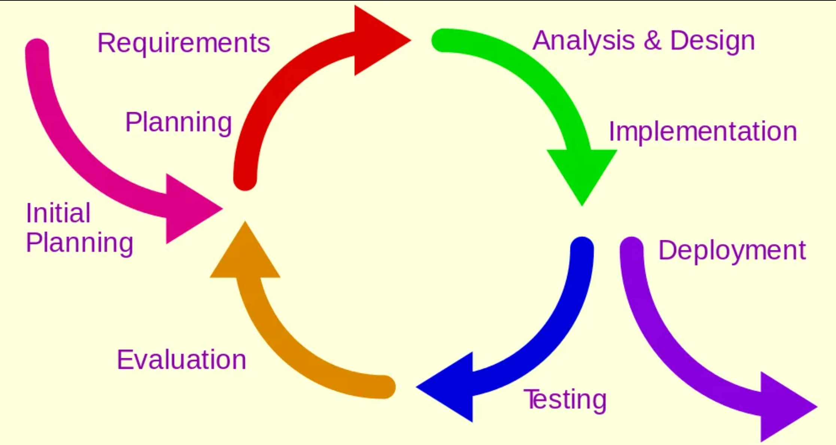

Figure 2: Iterative and Incremental Model
Reasons of using Iterative and Incremental Model:
    - Phased Approach: The project can be divided into multiple phases, such as data collection, data preprocessing, model development, model evaluation, and documentation. Each phase can be iteratively refined based on feedback and results from previous phases.
    - Feedback Loops: Regular evaluations of the model's performance allow for adjustments and improvements. For instance, after developing an initial LSTM model, the team can analyze its accuracy and modify the architecture or hyperparameters as necessary, iterating until satisfactory performance is achieved.
    - Risk Management: By breaking the project into smaller, manageable increments, risks can be identified and addressed early. For example, if data quality issues arise during the preprocessing phase, they can be resolved before moving on to model training.
    - Flexibility: This model allows for flexibility in responding to new findings or changes in project scope. If new data sources or features become available that could enhance the model, these can be incorporated into the project without major disruptions.

Assumptions
- Data Sufficiency for Training: The amount of historical data needed for more accurate prediction will be much higher. So, we are assuming the data we collect must be of more than 5 years.
- Closing Prices only: Since we are working on stock prices and in context of Nepal, there is no intraday, so we are taking only closing prices of the stock as data.
- While writing the code and during training and testing of our application, we will be taking data of only one stock and use it as the test subject.

Machine Learning Algorithms
Long Short-Term Memory (LSTM) algorithm is used in this project for predicting stock prices. Long Short-Term Memory (LSTM) networks are often considered better for stock market prediction compared to traditional models and other machine learning techniques because of following reasons:
- Ability to capture large sequential data and can learn long-term dependencies.
- It can handle Non-Linear and complex Patterns in the chart or prices
- It is more suited for time series data
- It has ability to learn from noise and volatility, since stock prices are often noisy and volatile
The study employs a Long Short-Term Memory (LSTM) neural network model for stock price prediction. The LSTM model is chosen for its ability to capture temporal dependencies and handle time-series data effectively [10]. Figure 3 shows the visualization of the architecture. The model architecture comprises the following layers. Input Layer: The input layer is configured to accept sequences of 60 days' worth of scaled closing prices. LSTM Layers: Two LSTM layers are used, with the first layer having 128 units and returning sequences to feed into the subsequent layer. The second LSTM layer has 64 units and does not return sequences. Dense Layers: Following the LSTM layers, two dense layers with 25 and 1 unit(s) respectively are added. The final dense layer outputs the predicted closing price. Compilation: The model is compiled using the Adam optimizer and mean squared error (MSE) as the loss function.

LSTM cell
The whole computation can be defined by a series of equations as follows:
it = σ (W i H + bi ) (1)
ft = σ (W f H + bf ) (2)
ot = σ (W oH + bo ) (3)
ct = tanh (W c H + bc ) (4)
mt = ft mt - 1 + it (5)
ht = tanh (ot mt) (6)

3.5.2. Model Training and Evaluation
The LSTM model is trained on the prepared training dataset with a batch size of 32 and 50 epoch. The training process involves adjusting the model's weights to minimize the loss function, thereby improving the accuracy of predictions . Model evaluation is conducted on the test dataset, where the model's predictions are compared against the actual closing prices. The root mean squared error (RMSE) is calculated to quantify the model's prediction accuracy . Lower RMSE values indicate better model performance, where n is the number of observations, yi is the actual value of the i-th observation, and yi is the predicted value of the i-th observation

Long Short-Term Memory (LSTM) algorithm is used in this project for predicting stock prices. Long Short-Term Memory (LSTM) networks are often considered better for stock market prediction compared to traditional models and other machine learning techniques because of following reasons:
- Ability to capture large sequential data and can learn long-term dependencies.
- It can handle Non-Linear and complex Patterns in the chart or prices
- It is more suited for time series data
- It has ability to learn from noise and volatility, since stock prices are often noisy and volatile

Data Collection
Since the API of official website of Nepal Stock Exchange (NEPSE) is not publicly available, all the necessary historical data will be collected from a website called ShareSansaar, a private company work in the field of stock market. We will be collected the OHLC(Open, High, Low, Closing) prices of the day for that stock of minimum 5 years.

Chapter 4: Implementation

4.1. Problems Faced

a. The x-axis of the graph is complete dark.
Reason: The datatype of Date was object, that’s why it wasn’t showing.
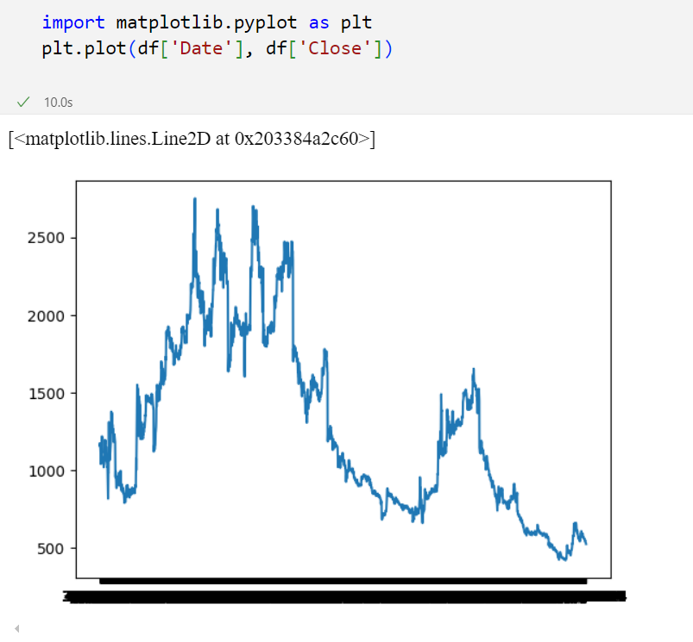
Solution: It’s datatype is converted into datetime.
Figure 3: Problem 1

4.2. Work Completed

TASK 1: Collection of Data
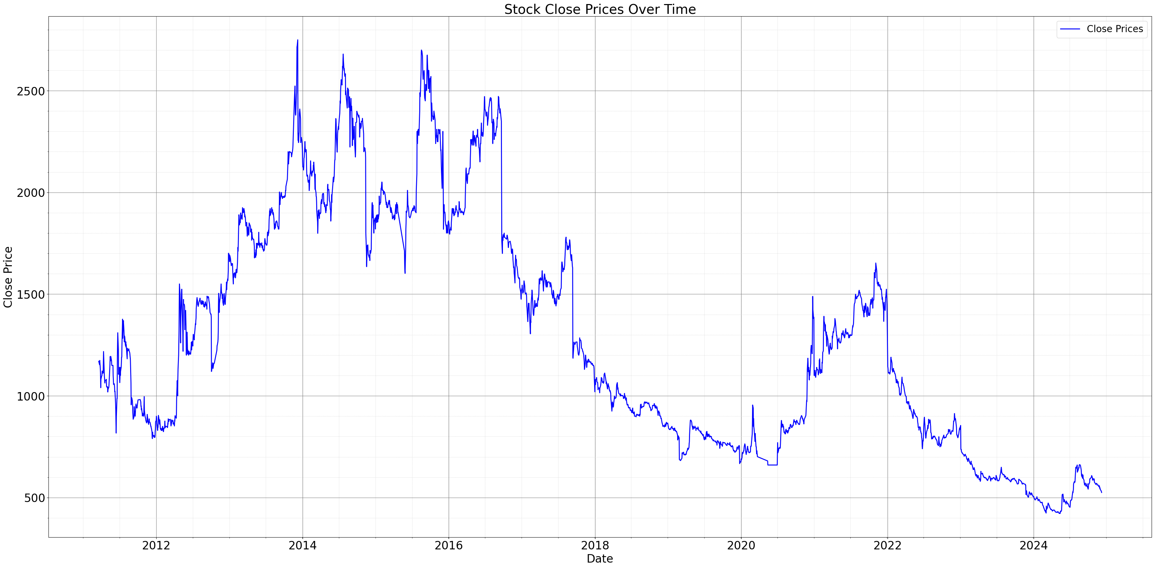
- Data has been collected and plotted the given data in graph.
Figure 4: Data collection chart

TASK 2: Preprocess the Data
- The closing price of each date is scaled using MinMaxScaler between 0 and 1.
- Window size of the dataset is set to 60 for our project.
- Then we have separated 80% of data for training model and remaining 20% for testing model.

TASK 3: Created a Stacked LSTM model
- At first, train and test data are reshaped into 3D matrix, as the tensorflow/keras sequential models takes 3D matrix as input
- Then, We have created Sequential LSTM model with following attributes:
  - LSTM layer 1: with 50 units neurons, which will pass sequences to 2nd LSTM layer
  - Dropout layers: It will set 20% of input units to zero to prevent overfitting.
  - Second LSTM layer: with 50 units neurons, and since it is last LSTM layer, it will pass no sequence.
  - Second Dropout Layers: 20% dropouts to further reduce overfitting.
  - Dense Layers: which will give predicted output.

4.3. Work Remaining
TASK 4: Predict the Test data and plot the output
TASK 5: Predict the future 30 days data and plot the output

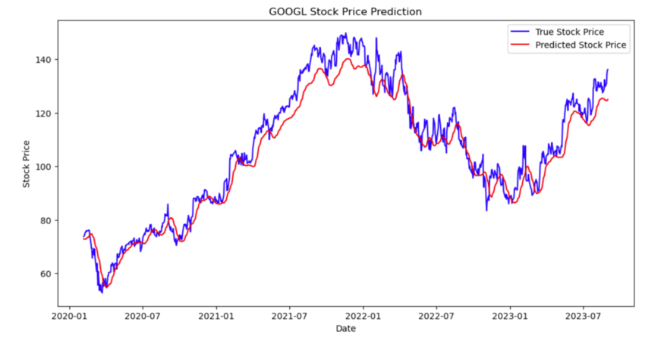
Chapter 5: Expected Output
Figure 5: Actual price vs Predicted price
Source: Datacamp.com [6]

After completion of our Model, we can draw the actual price and our predicted price alongside the historical data of that stock or index, of predict the price of upcoming 30 days.

5.1.1 Performance Metrics
Mean Squared Error (MSE):
MSE measures the average of the squared differences between the predicted and actual values. It penalizes larger errors more severely than smaller ones, making it useful for detecting major deviations in stock price predictions.
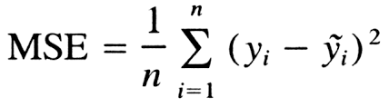
Formula:

Goal: Minimize the MSE to improve the accuracy of predictions.
Interpretation: Lower MSE indicates better model performance.

Chapter 6: Project Schedule

6.1. Schedule

Table 6.1 Gantt Chart
S.N. | Tasks | Month
1. | Discussion & Planning | Sept 20 - 24
2. | Project Setup & Literature Review | Sept 26 - | Oct 10
3. | Data Collection & Preprocessing |  |  | Nov 11 – 20
4. | Model Design & Development |  |  | Nov 30 – Dec 20
5. | Model Training & Evaluation |  |  | Dec 20 – Jan 10
6. | Optimization |  |  | Jan 10 – Jan 20
7. | Documentation, Report Writing & Submission | Sept 20 - 24 | Continue | Continue | Continue

Chapter 7: CONCLUSION
In this study, we explored the application of Long Short-Term Memory (LSTM) networks for stock market analysis and prediction, focusing on four major stocks: Everest Bank Limited (EBL), Chilime Hydropower Company Limited (CHCL) and Standard Chartered Bank Limited (SCB). Our research demonstrated the potential of LSTM models in capturing complex patterns and trends in stock price movements, leading to reasonably accurate predictions of future prices. The findings of this study hold significant implications for both academia and the finance industry.
For investors and traders, the insights gained from our model could aid in making more informed decisions, potentially leading to improved investment strategies and portfolio management.
In conclusion, our study underscores the potential of LSTM networks in stock market analysis and prediction, offering valuable insights for both researchers and practitioners in the field of finance. As machine learning continues to evolve, its application in financial markets holds the promise of unlocking new opportunities for understanding and predicting stock price movements.

REFERENCES
[1] “Heaton J.B., Polson N.G., Witte J.H. Deep learning for finance: deep portfolios”
Applied Stochastic Models in Business and Industry, 33 (1) (2017), pp. 3-12
https://scholar.google.com/scholar_lookup?title=Deep%20learning%20for%20finance%3A%20deep%20portfolios&publication_year=2017&author=J.B.%20Heaton&author=N.G.%20Polson&author=J.H.%20Witte

[2] Mondal, Prapanna & Shit, Labani & Goswami, Saptarsi. (2014). “Study of Effectiveness of Time Series Modeling (Arima) in Forecasting Stock Prices”. International Journal of Computer Science, Engineering and Applications. 4. 13-29.
http://dx.doi.org/10.5121/ijcsea.2014.4202

[3] Siami Namini, Sima & Siami Namin, Akbar. (2018). “Forecasting Economics and Financial Time Series: ARIMA vs. LSTM”.
https://doi.org/10.1109/BigData47090.2019.9005997
[4] Hiransha M, Gopalakrishnan E.A., Vijay Krishna Menon, Soman K.P.,NSE “Stock Market Prediction Using Deep-Learning Models, Procedia Computer Science”, Volume 132, 2018, Pages 1351-1362, ISSN 1877-0509,
https://doi.org/10.1016/j.procs.2018.05.050

[5] S. Mehtab, J. Sen and A.Dutta, “Stock price prediction using machine learning and LSTM-based deep learning models,” In Proc. of the 2nd Symposium on Machine Learning and Metaheuristic Algorithms and Applications, Chennai, India, October 2020.
http://dx.doi.org/10.36227/techrxiv.15103602
[6] Stock Market Predictions with LSTM in Python,
https://shorturl.at/Xg2fD

